**Lab 2: Setting Up the Database Context for a Retail Store**

Models/Category.cs :

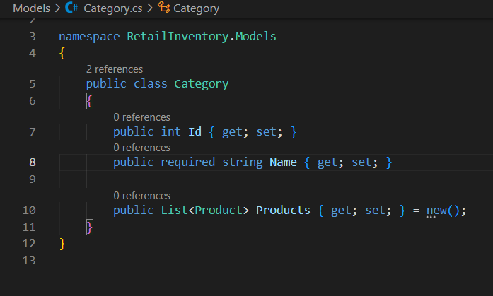

Models/Product.cs :

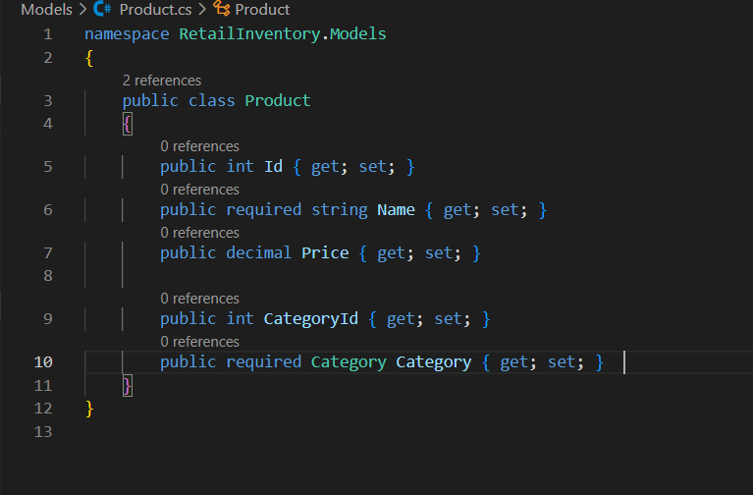

Data/AppDbContext.cs

